Lab#08
Implementation of switch case
statement in java
Objective
Implementation of switch case statement in java.
Lab Goals
To provide working insight into the usage of switch case statement in java programming:
a. Switch Statement.
Introduction to switch case statement
In Java, the switch statement is a control flow statement that allows you to select one of many code blocks to execute based on the value of a variable or an expression. It provides a concise way to handle multiple cases and avoid long chains of if-else statements. It has the following syntax.

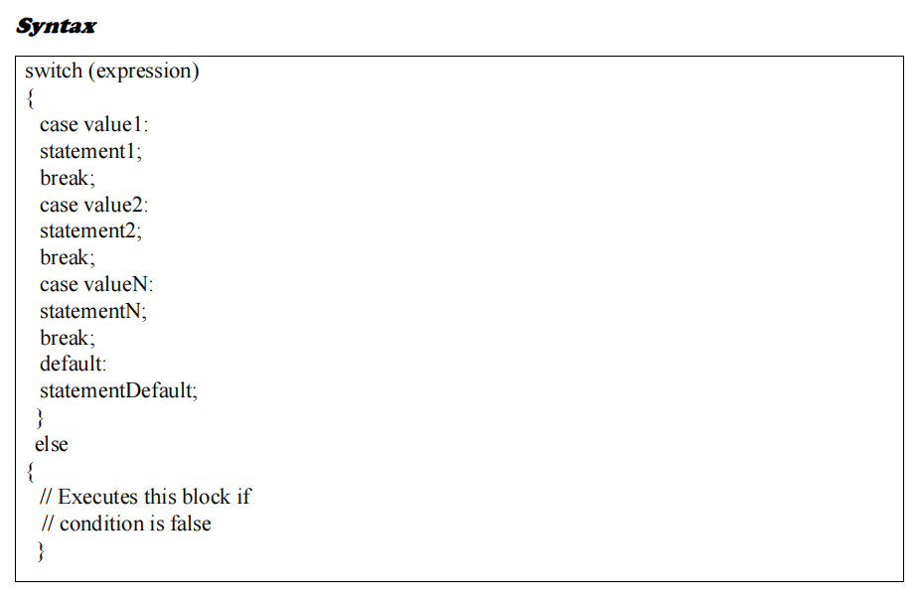

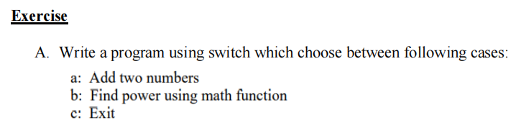
Program:
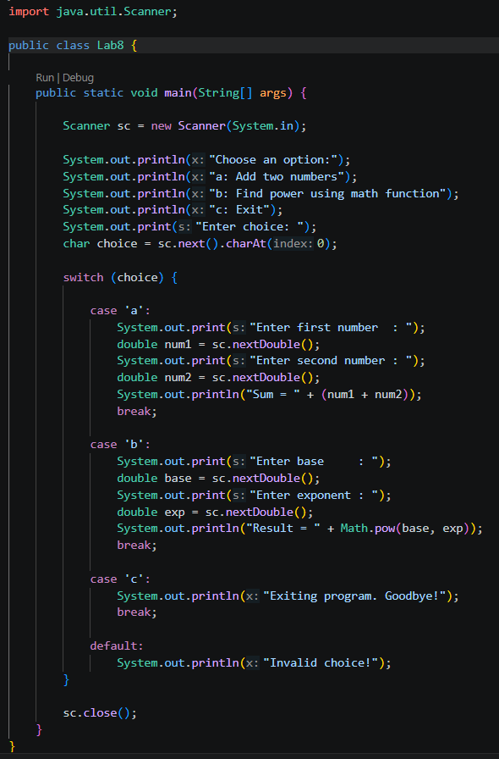
Output:
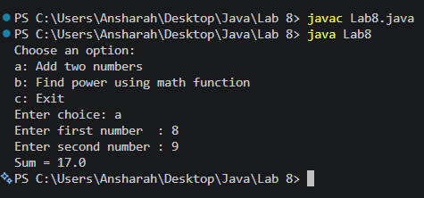

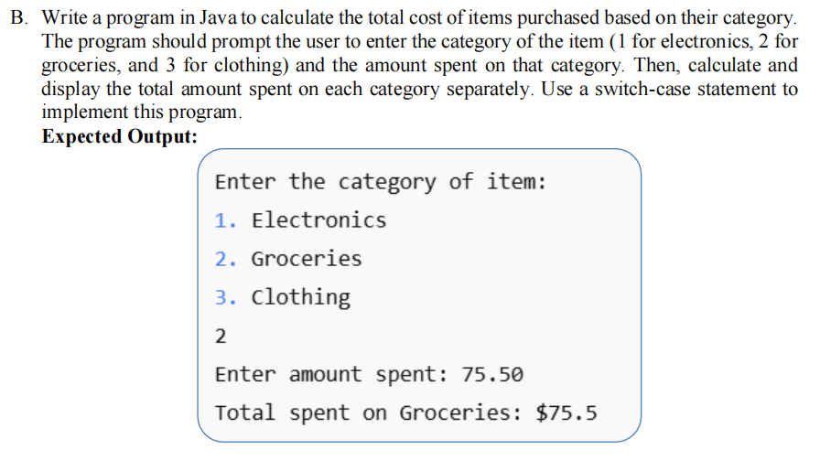
Program:
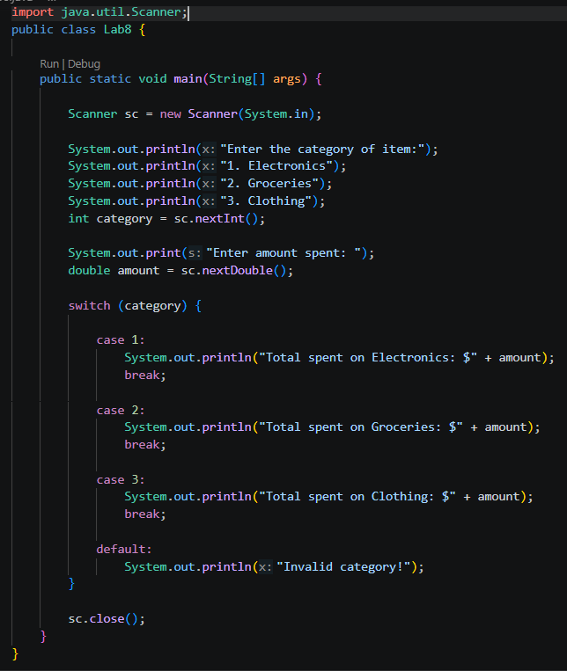
Output:
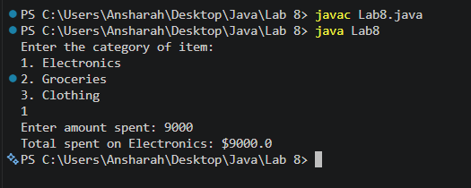
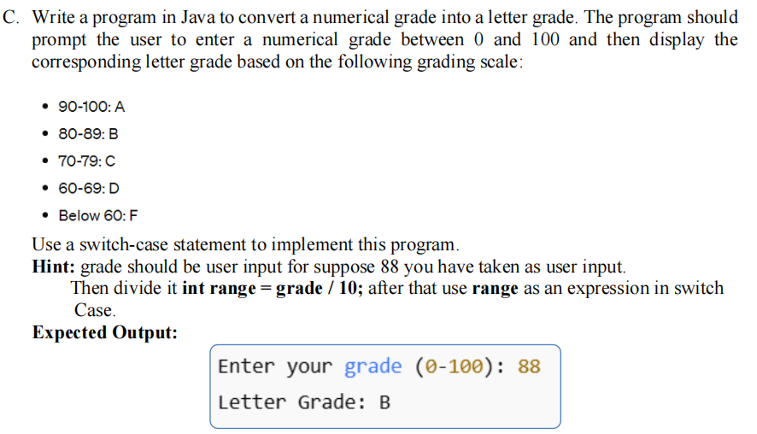
Program:
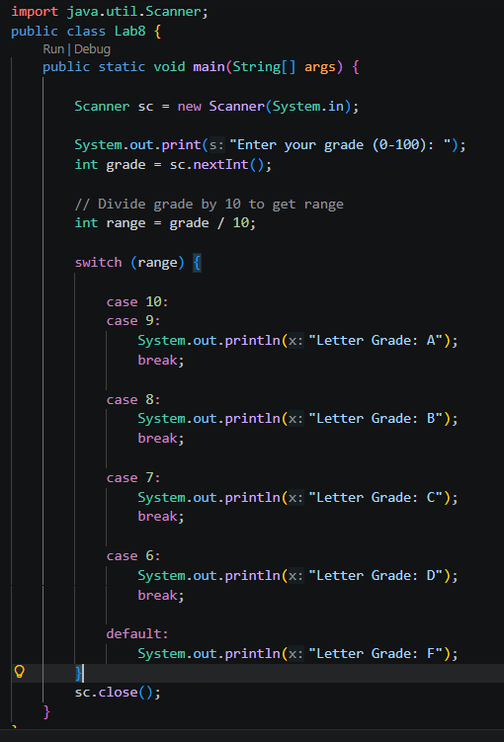
Output:
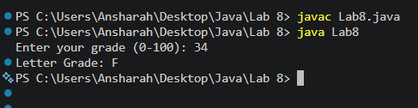

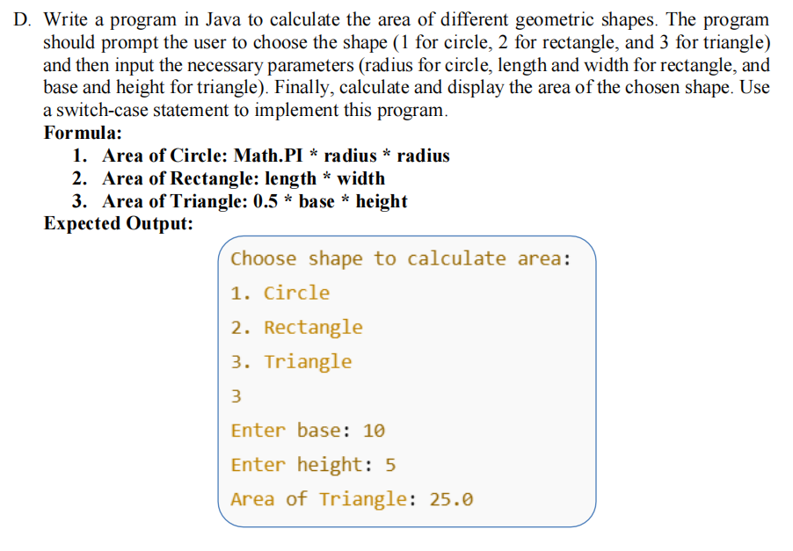
Program:
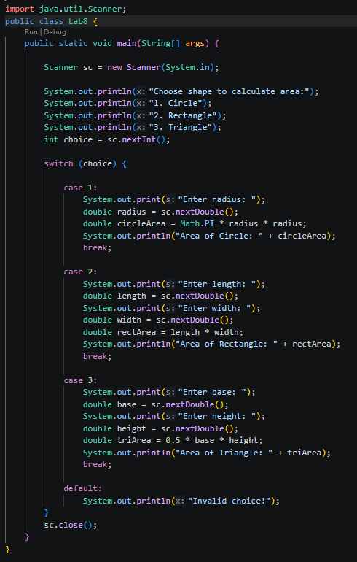
Output:
